Hotel Management System

Component-Based Computing (CS344 / CS344x)
Faculty of Computer Science
MSA University

Student  ID | Name | Signature
248311 | Farah Kinaz

Table of Contents
1. Project Overview
2. Problem Statement
3. Objectives
4. Functional Requirements
5. Non-Functional Requirements
6. System Architecture
7. Component Design
8. Database Design
9. REST API Documentation
10. System Workflow
11. User Interface Screenshots
12. Technologies Used
13. Conclusion
14. Future Improvements

1. Project Overview
Grand Hotel Management System is a full-stack, component-based web application that digitizes and centralizes all operations of a five-star hotel. Built with Java Spring Boot, MySQL, and a modern HTML/CSS/JavaScript frontend, it applies core software engineering principles including Inversion of Control (IoC), Dependency Injection (DI), and Interface-based component design.

2. Problem Statement
Hotels require efficient management of reservations, guests, staff, and billing. Manual systems lead to errors, inconsistency, and inefficiency. This system centralizes operations.

3. Objectives
- Design and implement a component-based architecture using Java interfaces, IoC containers, and Dependency Injection via Spring Boot annotations
- Build a RESTful API layer that exposes all hotel operations as HTTP endpoints
- Implement a role-based access control system with 11 distinct user roles, each with a dedicated dashboard and limited access scope
- Integrate a MySQL relational database using Hibernate ORM and Spring Data JPA with automatic schema generation
- Develop a responsive web frontend (HTML/CSS/JavaScript) that consumes the Spring Boot APIs and renders role-specific interfaces
- Demonstrate IoC and DI principles through interface injection across all service components
- Apply SOLID design principles throughout the codebase for maintainability and extensibility

4. Functional Requirements
- User authentication (login/logout)
- Reservation management (CRUD)
- Guest management
- Role-based dashboards
- Billing operations

5. Non-Functional Requirements
- Performance: Fast API response
- Security: Session-based authentication
- Scalability: Modular architecture
- Maintainability: Layered design
- Reliability: Persistent MySQL storage

6. System Architecture
The system follows a 3-layer architecture:
1. Presentation Layer (Frontend)
2. Application Layer (Spring Boot Backend)
3. Data Layer (MySQL Database)
Each component communicates via REST APIs.

7. Component Design
The system is divided into independent components:
- Services Component
- Security Component
- Customer Data Component
- Billing & Finance Component
- Staff Management Component
- DataBase Component
-Kitchen Component
-Payment Gateway Component (External)
Each component contains Controller, Service, and Repository layers.
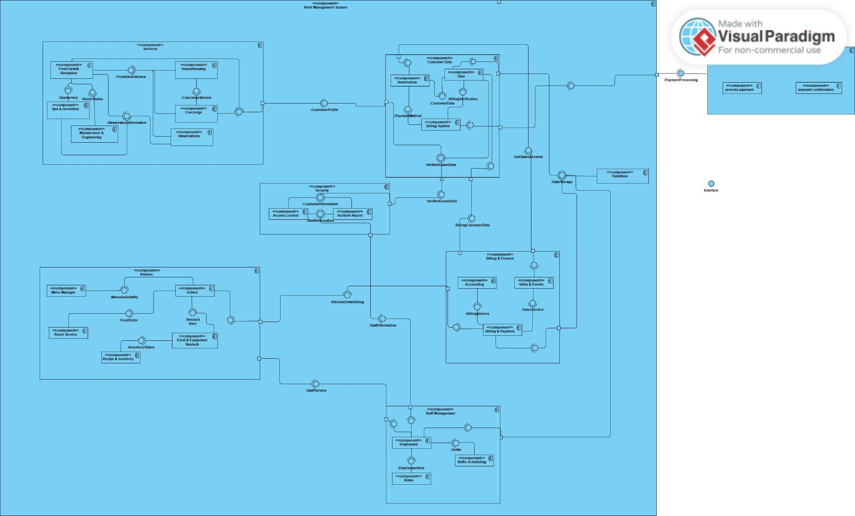

Each component has sub-components:
- Services:
  - Front Desk & Reception:
    - It’s for the receptionist in the hotel that responsible for the check-in/out the guests and can access reservation information if the guest had booked online
    - Provided Interface:
      - Room Status: provided for the Maintenance & Engineering component for room availability and if it’s organized or not
      - Front Desk Service: provided for House Keeping to inform that a guest checked-in for room_ID to make sure to organize it, Concierge if the guest had to report a complaint, and Reservation
    - Required Interface:
      - Spa & Recreation: required from Spa & Recreation if the guest requested additional service from this building so it will inform the Front Desk & Reception about it
      - Reservation Information: required from Reservations so can easily check if the guest booked online and the booking information
      - Customer Profile: required from the Customer Data on the Data so it can access easily that the guest data is verified and for the reservation history
  - Spa & Recreation:
    - It’s for storing the guest request for additional services and then informs the Front Desk & Reception for check-out
    - Provided Interface:
      - Spa & Recreation: Provided for Front Desk & Reception to inform if the guest requested additional services
    - Required Interface:
      - Reservation Information: Required from Reservation to check if the guest actually booked for additional services

  - House Keeping:
    - It’s for house keeping to know which room_ID is checked-in and make sure it’s prepared
    - Provided Interface:
      - Concierge Service: provided for Concierge to report a complaint they’ve witnessed
    - Required Interface:
      - Front Desk Service: required from Front Desk & Reception if the guest had to report a complaint
  - Concierge:
    - Used to store the complaints anyone requested
    - Required Interface:
      - Front Desk Service: required from Front Desk & Service if the guest had to report a complaint
      - Concierge Service: required from House Keeping to report a complaint they’ve witnessed
  - Reservation:
    - Used to store and retrieve any booking occurred either on campus or online
    - Provided Interface:
      - Reservation Information: provided for Front Desk & Reception to check if a guest had a reservation
    - Required Interface:
      - Front Desk Service: required from Front Desk & Reception to store a reservation a guest just booked
  - Maintenance & Engineer:
    - Used for handling requests for rooms and facilities
    - Required Interface:
      - Room Status: required from Front Desk & Reception to identify which room need maintenance

- Customer Data:
  - Reservation:
    - Used to store a reservation customer booked
    - Provided Interface:
      - Customer Data: provided for Data to store reservation in the customer account
      - Payment Method: provided for the Billing System to store the billing data
      - Get Sales & Events: provided for the Billing & Finance Component on Sales & Events if there is a voucher or sales exist
  - Data:
    - Used to store the guest data
    - Provided Interface:
      - Verified Guest Data: provided for Services as a Customer Profile as it provide the verified guest data, and in Security for incident report and access control for securing the data and access
      - Billing Customer Data: provided for Billing & Finance Component to send the payment data
    - Required Interface:
      - Customer Data: required from Reservation to store a new booking a guest booked online
      - Billing Verification: required from the Billing System to check if the payment method is verified or not
      - Data Storage: required from the DataBase Component to access a database to store the data

  - Billing System:
    - Used to check if the payment method is accepted or not
    - Provided Interface:
      - Billing Verification: provided for Data to inform if the payment method is verified or not
    - Required Interface:
      - Payment Method: required from Reservation to get the payment information
      - Payment Processing: required from the External Payment Gateway to check if the bank accepted the transaction or not
- Security:
  - Access Control:
    - Used to manage access depending on the role of employees and guest
    - Required Interface:
      - Customer Information: required from Customer Data to validate guest identity
      - Staff Information: required from Staff Management for employee access levels
  - Incident Report:
    - Used to record incidents
    - Required Interface:
      - Customer Information: required from Customer Data for guest-related incidents
      - Staff Information: required from Staff Management for staff-related incidents
- Billing & Finance:
  - Accounting:
    - Used to calculate the payments occurs when booking
    - Required Interface:
      - Billing Service: required from Billing & Payment to get the transaction that occurred
  - Sales & Events:
    - Used when an event, sales, or vouchers exists to reduce the total cost
    - Provided Interface:
      - Sales Service: provided for the Billing & Payment to inform if a sales or vouchers if exists
    - Required Interface:
      - Get Sales & Events: required from Customer Data Component in Reservation for when the guest has a voucher
  - Billing & Payment:
    - Used for storing every transaction occurs
    - Provided Interface:
      - Billing Service: provided for Accounting to give the transactions occured
    - Required Interface:
      - Sales Service: required from Sales & Event to get the sales or vouchers if exists
      - Kitchen Order Billing: required from the Kitchen Component on Orders to be informed an order occurred
      - Data Storage: required from the DataBase Component to access a database to store the data
- Kitchen:
  - Menu Manager:
    - Used to manage the daily menu & restock ingredients
    - Provided Interface:
      - Menu Availability: provided for Orders to inform what needs to be restocked and order it
  - Room Service:
    - Used to order food that delivers into guest’s room
    - Provided Interface:
      - Food Order: provided for Orders to order food that delivers into guest’s room
  - Recipe & inventory:
    - Used to store the food recipe and inventory
    - Provided Interface:
      - Inventory Status: provided for Food & Equipment Restock to send information about an equipment or inventory status

  - Food & Equipment Restock:
    - Used to check the equipment and ingredients availability
    - Provided Interface:
      - Restock Alert: provided for Orders to inform if anything needs to be restocked
  - Orders:
    - Used to order products and ingredients that need to be restocked and for guests that orders meals that delivers to room_ID
    - Provided Interface:
      - Kitchen Order Billing: provided for Billing & Finance to store the order reciept/ transaction
    - Required Interface:
      - Menu Availability: required from the Menu Manager to check the availability of the menu products
      - Food Order: required from the Room Service for the guests who orders food that delivers into guest’s room
      - Restock Alert: required from the Food & Equipment Restock inform if anything needs to be restocked
- Staff Management:
  - Employees:

    - Provided Interface:
      - Staff Information: provided for Security Component for Incident Report and Access Control
      - Staff Service:
    - Required Interface:
      - Employees Role: required from Roles to get every employee’s role
      - Shifts: required from Shifts Scheduling to get every employee’s shift
      - Data Storage: required from the DataBase Component to access a database to store the data

  - Roles:
    - Used to define every employee’s role
    - Provided Interface:
      - Employees Role: provided for Employees to inform evey employee’s role
  - Shifts Scheduling:
    - To define every employee’s shift
    - Provided Interface:
      - Shifts: provided for Employees to send every employee’s shift
- DataBase:
  - Database:
    - Used to give storage access to users
    - Provided Interface:
      - Data Storage: provided for Customer Data, Billing & Finance, and Staff Management Components to give them access to store their database
- Payment Gateway (external):
  - External Payment Gateway:
    - Used to communicate with the guest’s bank when processing a payment and returns with the confirmation
    - Provided Interface:
      - Payment Processing: provided for the Customer Data Component in Billing System to send the confirmation from the bank
8. Database Design
Main tables:
- users(id, username, password, role)
- reservations(id, check_in, check_out, guest_email, room_type)
- guests(id, name, email, phone)

Column | Type | Constraint | Description
guest_id | INT | PRIMARY KEY, AUTO_INCREMENT | Unique guest ID
guest_name | VARCHAR(255) |  | Full name of guest
guest_mail | VARCHAR(255) |  | Guest email addres
check_in | VARCHAR(255) |  | Check-in date strin
check_out | VARCHAR(255) |  | Check-out date stri
room_number | INT |  | Assigned room num

9. REST API Documentation

Method | Endpoint | Description
POST | /api/auth/login | User login
GET | /api/reservations | Get all reservations
POST | /api/reservations | Create reservation
DELETE | /api/reservations/{id} | Delete reservation

10. System Workflow
- User opens http://localhost:8080/app.html in browser
- Login page is displayed with username/password fields and demo account buttons
- User enters credentials and clicks Sign In
- Frontend sends POST /api/login with JSON body to Spring Boot
- AuthController queries UserRepository.findByUsernameAndPassword()
- If found: Spring Boot returns the User object (including role) as JSON
- If not found: returns HTTP 401 Unauthorized
- Frontend reads the role field and renders the role-specific dashboard
- Sidebar navigation is dynamically built based on the role configuration

11. User Interface
Includes login page, admin dashboard, reservation system, and staff interface.
(Screenshots to be inserted here)
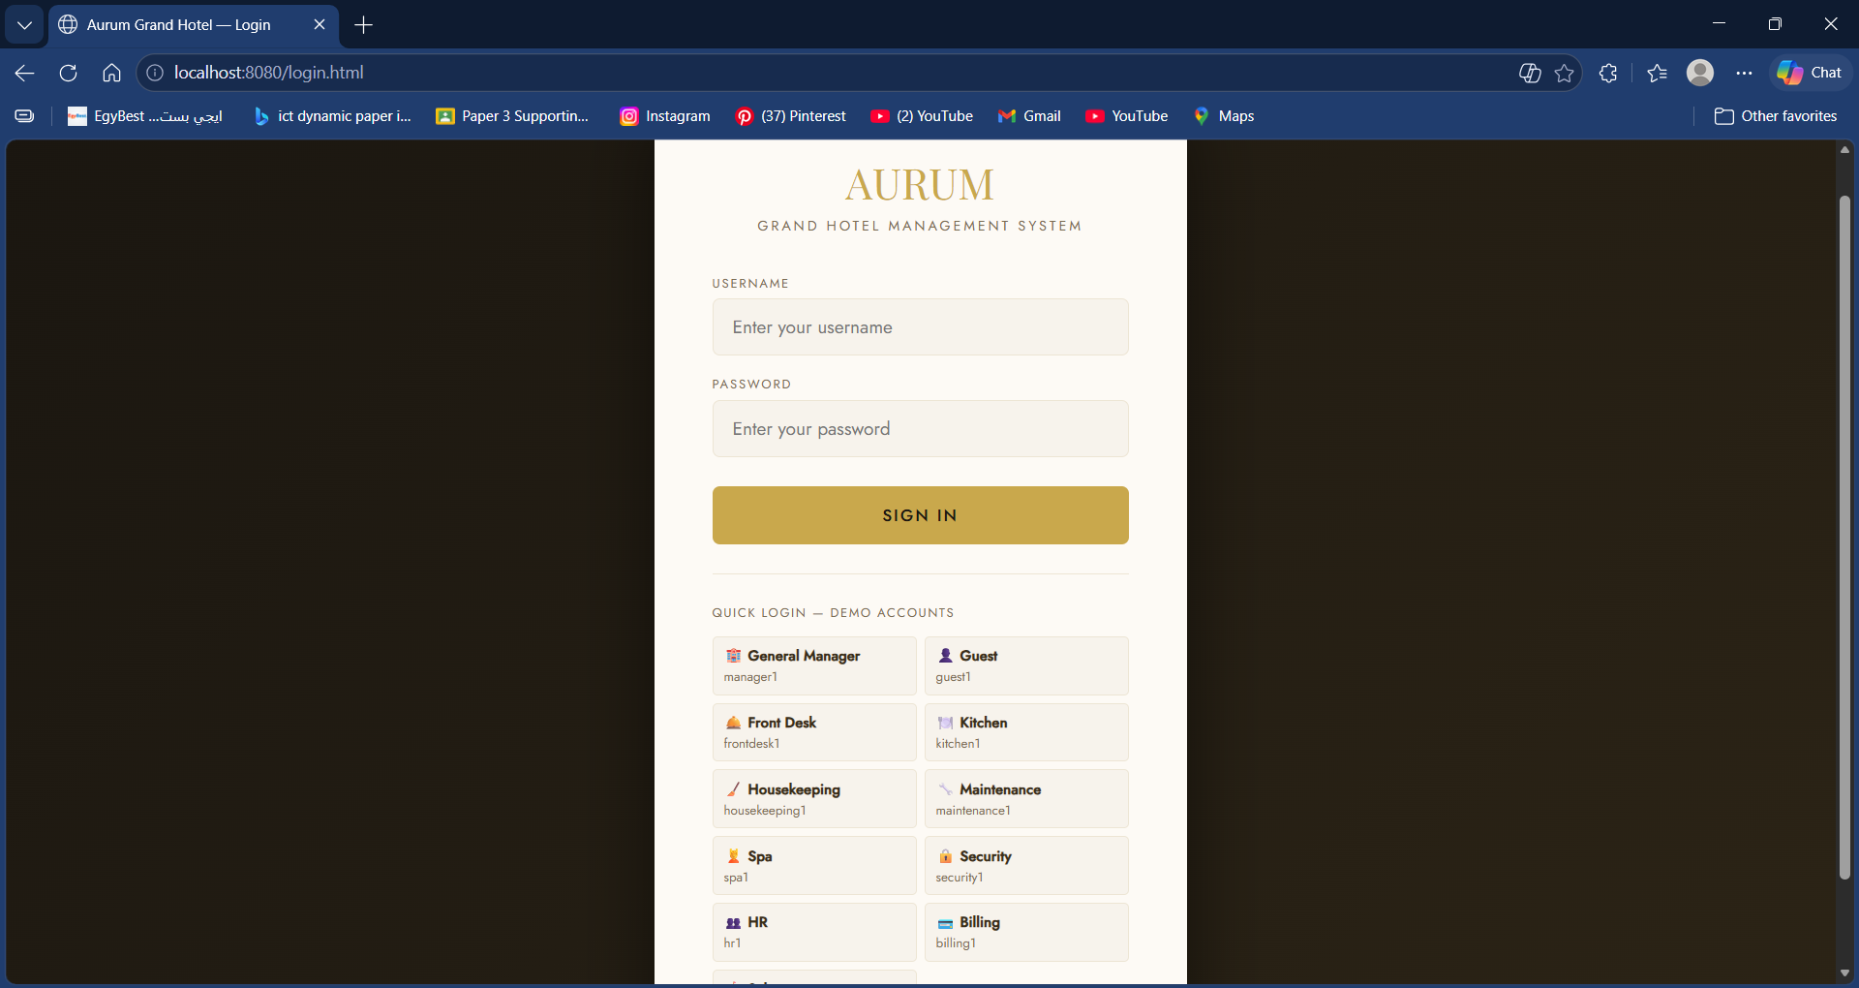

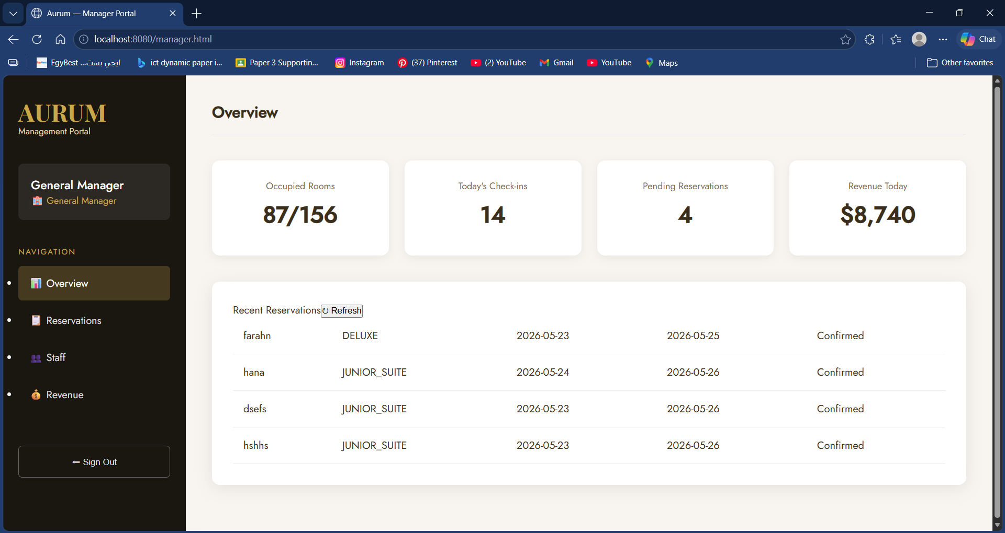

12. Technologies Used
- Java Spring Boot (Eclipse)
- MySQL
- HTML/CSS/JavaScript
- REST APIs

13. Conclusion
This project demonstrates a complete component-based software system with full-stack integration, applying modern software engineering principles.
      - Inversion of Control (IoC): Spring Boot manages all component lifecycles through its application context
      - Dependency Injection (DI): All service components are injected via @Autowired on interface types, never on concrete classes
      - Interface-Based Design: Every component exposes its functionality only through Java interfaces (IReservation, IBillingSystem, IHouseKeepingService, etc.), ensuring loose coupling
      - Separation of Concerns: Each package handles exactly one business domain; changing billing logic does not affect kitchen or security components
      - Database Integration: Three MySQL tables (users, guests, reservations) are auto-generated and managed by Hibernate ORM

14. Future Improvements
- Add Spring Security with encryption
- Improve UI responsiveness
- Add analytics dashboard
- Add the rest of the Staff Role in the Front-end

